HSBC On-Line Documents Tracker Guidelines (Term under LC, DA, DP and doc send through HSBC Bank)
Prior to this, the HSBC reference# must be available from Documentation Department.

STEP 1: PLEASE ACCESS TO BELOW HSBC WEBSITE

http://www.hsbc.com.my/1/2/business-banking/commercial-banking

STEP 2: PLEASE LOG IN / CLICK TO COMMERCIAL SECTION

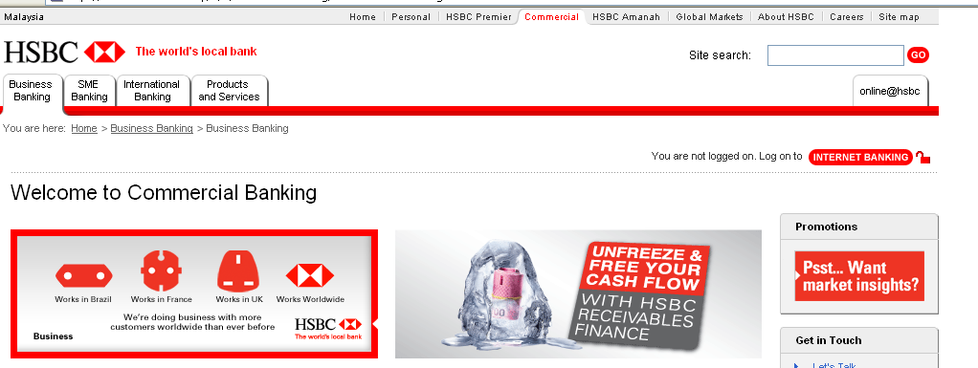

STEP 3: UNDER THE COMMERCIAL SECTION / PAGE, PLEASE CLICK INTO Trade and Supply Chain (at the left side, bottom of the page)

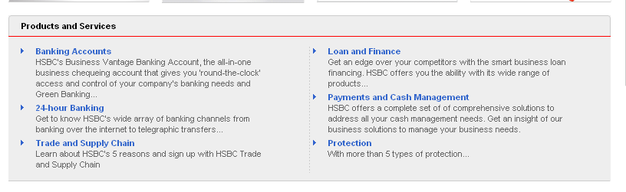

STEP 4: ON THE TRADE AND SUPPLY CHAIN PAGE, PLEASE LOG IN TO DOCUMENT TRACKER

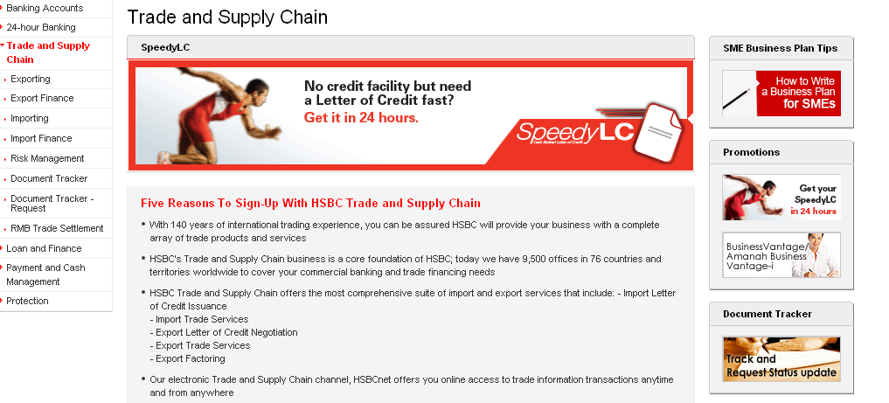

STEP 5: UNDER DOCUMENT TRACKER SECTION, YOU WILL COME TO BELOW PAGE

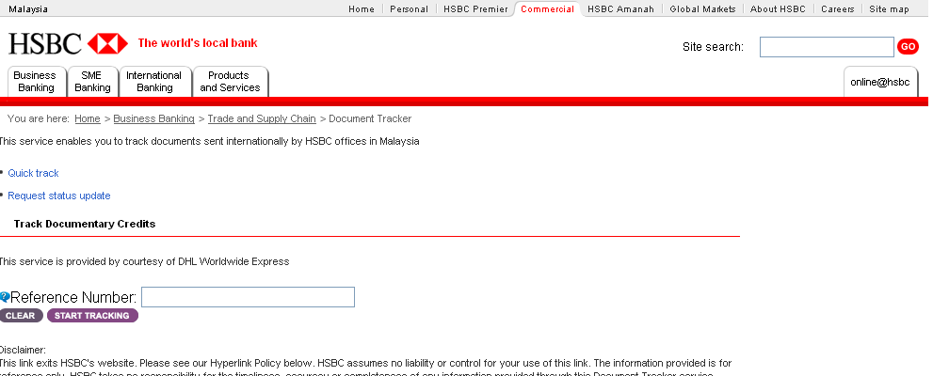

STEP 6: PLEASE KEY IN THE REFERENCE NUMBER FROM HSBC BANK & START TRACKING
- The reference number is available from Documentation OIC/HSBC Bank for those shipping documents send through HSBC bank for term under LC, DA and DP

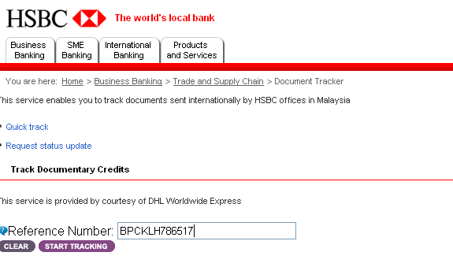

(1) TO KEY IN THE REF# FROM BANK
(2) CLICK START TRACKING

FINAL RESULT: YOU WOULD FIND THE AWB# & STATUS OF THE DOCUMENTS AS PER BELOW

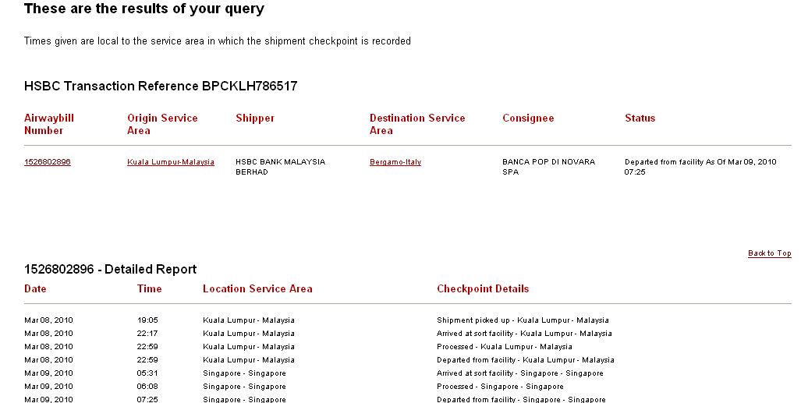

Prepared by: Siah Ming Lei
Date: 10th March 2010

